Official league roster - Basketball
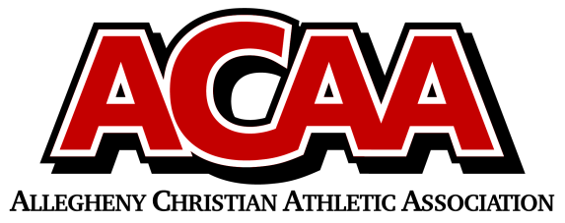

School Name: Columbia County Christian
Team Colors: Navy Blue/Maroon
Overall Wins ___ Losses ____ Ties ___
ACAA Wins ___ Losses ____ Ties ___ OPPONENT: __________________________
Date: _________
Number | Name | Year | Position | Height | Homeschool
11 | Elijah Beishline | 12 | G/F | 6’3”
10 | Chandler Davis | 12 | G/F | 5’10”
25 | Clay Farley | 12 | F | 6’2”
15 | Hunter Fritz | 12 | G/F | 5’11”
12 | Jaksen Kline | 12 | F | 6’1”
22 | Moxley Runkle | 12 | F | 6’2”
24 | Sharyf Davies | 11 | F | 5’11”
4 | Owen Lenker | 11 | G | 5’8”
2 | Lyman Runkle | 10 | F | 5’8”
3 | Pierce Cughan | 9 | G/F | 6’2”
5 | Alex Kelly | 9 | G | 5’7”
20 | Eli Lenker | 9 | G | 5’8”

Head Coach: Jim Cughan
Asst. coach: Gary Fritz
Asst. coach:

